Barcoding Magazines
Created January 2018. Revised March 2023.

If you are barcoding many magazines at one time you will want to change the properties under Add/Edit Item (right click and select properties). Remember not to save properties when it asks you as you close Workflows later.

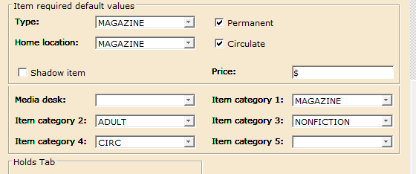

To search for a magazine title, select Exact search and then enter the title with the year.
Example: People 2023
This will take you directly to the bib record instead of having to select from a list.

Select Add call number at the bottom of the screen. This will display a generic call number/item record for your library and will need to be edited. The call number needs to be entered as described below:

Call Numbers for Magazines

To get the magazine issues to display in the correct date order, the call number must begin with date in number format followed by the month of the issue. Need to use a 2-digit number for the month.

Examples:

Issue Date on the Magazine | Call Number Format
January, 2013 | 01/13 January
January 7, 2013 | 01/07/13 January 7
March, 2013 | 03/13 March
June 16, 2013 | 06/16/13 June 16
August 16-August 30, 2013 | 08/16/13 August 16-August 30
January 30-February 6, 2013 | 01/30/13 January 30-February 6
November/December 2013 | 11/13 November-December
Winter 2013 | 01/13 Winter
Spring 2013 | 02/13 Spring

Change the Class Scheme to ASIS. Scan in the barcode and you should be done.

If you don’t want the most current issue to circulate this can be accomplished by checking the magazine out to user Magazine-C. This shows in the catalog as current issue and blocks check out. REMEMBER: when a new issue is received the past issue must then be discharged so it can be circulated.

